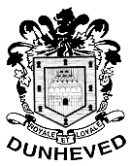

Dunheved Golf Club
Links Rd, St Marys.
Email: dunhevedladies@hotmail.com Fax: 9623 0230 Ph : 9623 0239

Choc-A-Holics Ladies Open Day
3 Person Teams Event
Stableford (1-2-3)

**New Event** Visitors Team Trophy

THURSDAY 16th AUGUST 2012
$16 per person

ALL PRIZES ARE CHOCOLATE
Entries close; 3rd August 2012 Starting time from 8.30am
Player 1 | Hcap | Player 2 | Hcap | Player 3 | Hcap | Player 4 | Hcap | Time

