**ISPS Handa Women’s**

**Australian Open Championship at Victoria Golf Club**

**Teed Up Tour**

**14th – 17th February 2014**

**3 NIGHTS / 4 DAYS / 2 GOLF GAMES / CAR HIRE**

**Fri14th February** Arrive Melbourne Airport

Pick up Thrifty Hire Car

Golf at Huntingdale Golf Club with pull buggy

**Check in:** Mercure Melbourne Treasury Gardens 4 star – 3 nights

**Sat 15th February** Golf at Sandhurst Golf Club with shared motorised cart

**Sun 16h February** Day at the Tournament

Champions Cocktail Party

**Mon 17h February** Check out of hotel and return hire car

**Tour Ends**

**ACCOMMODATION**

**Mercure Melbourne Treasury Gardens**

Garden View Room 1 King Bed

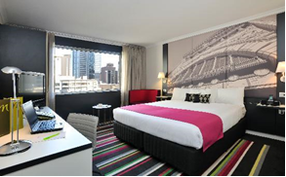Mercure Melbourne Treasury Gardens is located in the centre of Melbourne, near State Parliament and overlooking the picturesque Treasury Gardens.

It’s the perfect place to stay while exploring Melbourne's attractions such as Federation Square, the MCG and Parliament House. Also it’s in a prime location for discovering Rod Laver Arena, National Sports Museum, National Gallery of Victoria, Melbourne Aquarium and the renowned shopping boutiques on Collins Street.

The hotel features 164 rooms, all with Internet

access and many with Treasury Garden views.

There’s also Lime Restaurant and Bar.

**GOLF GAMES**

**Huntingdale Golf Course**

18 Holes, Par 72, ACR 74, 6340m

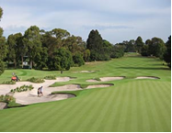Huntingdale is one of the most famous private golf clubs in Australia. Situated in the heart of Melbourne's famous Sandbelt the course is a very tight driving course, with the hard and fast greens that are so typical of the golf courses in the region. The course was recently renovated to improve drainage and to make it more challenging. A memorable finishing stretch of holes with plenty of variety in design. Home to the Australian Masters and played host to some of the most famous names in international golf, including Jack Nicklaus, Greg Norman, Ian Baker-Finch, Nick Price and Tiger Woods. The greens are true and fast and are generally kept in Masters condition throughout the year.

**Sandhurst Golf Course**

NORTH:18 Holes, Par 72, 6478m

CHAMPIONSHIP: 18 Holes, Par 72, 6240m

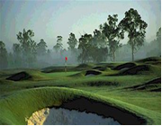

Designed by world-renowned design team, Thomson & Perrett, two championship golf courses, the North Course and the Champions Course.

Emphasising strategic shot making and providing a searching test of golfers short game skills, the open styled North Course features large sprawling greens, where getting to the putting surface is just the start of the challenge! Borrowing from the traditions of Scotland the course has several distinct features such as the Wall surrounding the 3rd green and the Burn (reminiscent of St Andrews) which dissects the 9th fairway.

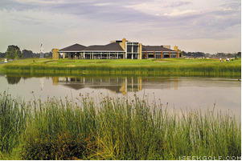Utilising a single, native couch on the fairways provides the North Course with superb conditioning and playing surfaces all year round. Also the home of the PGA of Australia.

In an innovative first for golf course architecture in this country, Thompson & Perrett designed the Champions Course in a dedication to past champions of the Professional Golfers’ Association of Australia.

Some of the most notable features of the Champions Course at Sandhurst Club are the gentle sandbelt style fairway contours, coupled with the open fronts to greens, and substantially tree lined fairways

**“Champions Cocktail Party”**

Join the players and celebrate a fantastic weekend with drinks and finger food.

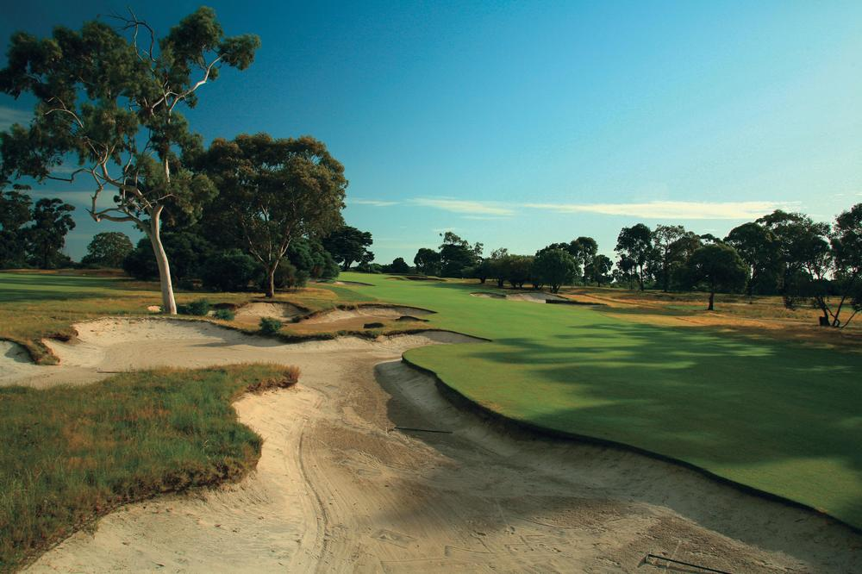



**INCLUSIONS**

* 3 nights’ accommodation Mercure Melbourne Treasury Gardens 4 star

Garden View Room with 1 King Bed / 2

* Full buffet breakfast and hotel parking daily
* Day attending theISPS Handa Women’s Australian Open Championship
* 2 golf games including a pull buggy/shared motorised cart where applicable
* Champions Cocktail Party on the Sunday night
* 4 day car hire – Thrifty Ecar Economy 3 door auto hatch

**COST**

Double / Twin Share: **$680 per person**

Single Supplement: **$995 per person**

**TERMS AND CONDITIONS**

The prices quoted in this itinerary are subject to change and will be based on pricing and availability around the dates that you wish to travel.

**ADDITIONAL INFORMATION**

Some of the times on this itinerary may change, but Teed Up Golf Tours will advise you of any changes as they are known. To make the most of your time while on tour, please be ready for departure and pick-ups each day at least 10 minutes before the times stated on your itinerary to utilise the group transfers and ensure everyone makes the scheduled tee times etc otherwise you will need to make alternative transfer arrangements at your own cost. There are some early morning starts and while we know you are on holiday we also know you want to make the most of your golf on these amazing courses.

**WET WEATHER REFUNDS**

Refunds do not apply if you choose not to play due to bad weather.

**TRAVEL INSURANCE**

If you need Travel Insurance for this tour or you would like an annual policy to cover all your trips then just click here <http://chartistravelinsurance.com.au/teedup/default.aspx> & you can get a quote within seconds from our recommended Insurer Chartis. If you are happy with the quote you can continue ahead & purchase the cover within a few minutes. This policy covers golf clubs up to a value of $3000, whereas many other policies only cover clubs to $500.

**DEPOSITS**

To secure your group’s place on this tour full payment for the entire group is required and must accompany the booking form.

**CANCELLATIONS**

Cancellations by the client must be in writing to Teed Up Golf Tours and are subject to the following forfeit of cost per person:

* Cancellation 60 days or more before departure date: 50% of the package value lost
* Cancellation between 60 days and departure date: 100% of the package value lost

Some providers and suppliers require full payment at time of booking. In these cases no refunds will be possible.

**DISCLAIMER**

This itinerary is accurate at time of compilation. Details may change due to circumstances outside our control. Golf courses and accommodation may change depending on availability but will be replaced by similar standard courses and hotel. Timings and order of days are also subject to change. Packages are marketed on behalf of Teed Up Travel License number 2TA4733 PGA Travel is not itself a transport, tour, event or accommodation provider. It acts only as an agent for those service providers.

**ISPS Handa Women’s Australian Open Championship – AF2008**

**Club Captain Details**

|  |  |  |
| --- | --- | --- |
| Full Name | **M/F** | |
| Golf Club |  | |
| Daytime Phone |  | Mobile Number |

**Double / Twin Share**

|  |  |  |  |
| --- | --- | --- | --- |
| **Name** | **Name of Room / Share With** | **Double or Twin** | **Cost** |
|  |  |  | $680 pp |
|  |  |  |  |
|  |  |  |  |
|  |  |  |  |
|  |  |  |  |
|  |  |  |  |
|  |  |  |  |
|  |  |  |  |
| **Total Amount Payable** | |  |  |

**Single**

|  |  |
| --- | --- |
| **Name** | **Cost** |
|  | $995 pp |
|  |  |
|  |  |
|  |  |
|  |  |
| **Total Amount Payable** |  |

**Payment Information:**

To secure your group’s place on this tour full payment for the entire group is required and must accompany the booking form.

**Payment Method (check one):** Cheque made payable to Teed Up Golf Tours

Direct deposit Westpac BSB: 032085 A/C: 217490 **Ref Code:** **AA1051 & your Club name is critical.**

Credit Card - Visa & MasterCard (2% fee applies) Amex (2.8% fee applies)

|  |  |  |
| --- | --- | --- |
| Card Type: Name On Card: | | |
| Card No.: | Expiry: | CCV No: |

By signing below I give my authority to charge the payment methods listed above and I acknowledge, understand and accept all the booking terms and conditions above and those that are listed in Teed Up Golf Tours’s full terms and conditions at [www.teed-up.com](http://www.teed-up.com) and I consent to Teed Up Golf Tours adding me to their mailing list to receive information on specials and updates occasionally.

Signature: _______________________________________ Date: ___/___/______

**Fax to: 02 8458 9005**

**Post to: Teed Up Golf Tours** **5/105 Alexander St Crows Nest NSW 2065  
 Scan and email to:** [info@teed-up.com](mailto:info@teed-up.com)

Marketed on behalf of Teed Up Travel License Number 2TA4733