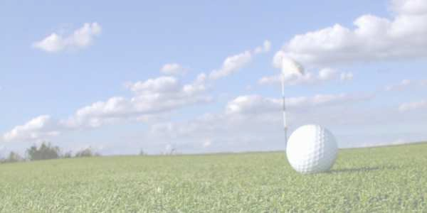COMPETITION DETAILS

2017
Sunshine Coast & South Burnett District Mid-Amateur
& Senior Championships
36 HOLE STROKE EVENT
(Maximum Handicap 15)

- Two stroke rounds of 18 holes being conducted on 30th April & 1st May, 2017
- The Championships are open to golfers who hold a GA Handicap - Maximum 15.
- Age Divisions (As of first day of Championships) Lower Mid-Amateur: 30-44 years
Upper Mid-Amateur: 45-54 years Senior: 55 years and over
- The winners will be the lowest gross score in each of the Lower-Mid Amateur, Upper Mid-Amateur and Senior Divisions. The lowest 36 hole Gross score from the Lower and Upper Mid-Amateur Divisions will be crowned Sunshine Coast & South Burnett District Mid-Amateur & Senior Champions
- In the event of a tie for the Championship a sudden death play- off will be held over holes 1, 17, & 18 until a winner has been established.
- In the event of a tie for the Championship Runners Up, and Nett Winners and Runners Up, a countback will be done on the last 18 holes - then the last nine.
- A 36 hole handicap event winner in Lower Mid-Amateur, Upper Mid-Amateur and Seniors will be run in conjunction. Handicap will be the player’s starting daily handicap for this event.
- Motorised transport is permitted and all players are eligible to win gross and nett events.
- The use of electronic measuring devices is allowed.
- $70.00 entry fee for Championships to be paid with nominations by 22nd April and covers all events and catering.

CHAMPIONSHIP SPONSORS
Carlton & United Breweries
Sunshine Coast & South Burnett District Golf Association Get Tapped - Phil & Luke Plowman

to be played
SUNDAY 30th APRIL & MONDAY 1st MAY CALOUNDRA GOLF CLUB
Shotgun Start 11.30am Sunday followed by BBQ Dinner
7.00am Breakfast Monday Followed by Shotgun Start at 8.00am
Nibble Platters & Presentation on completion of play
ENTRIES CLOSE – SATURDAY 22nd APRIL 2017
PLEASE FAX or EMAIL (with Credit Card Details), or POST ENTRY (with payment) to ..
The Secretary Manager Caloundra Golf Club
PO Box 92, CALOUNDRA 4551
FAX 07 5492 8070
Email: manager@caloundragolf.com.au
ABN 50 972 352 486

Please photocopy this ‘inside section’ of the Entry Form and send with payment or Email /Fax with Credit Card details
2017 Sunshine Coast & South Burnett District Mid-Amateur & Senior Championships Sunday 30th April & Monday 1st May 2017
ENTRY FEE: $70.00

Competitor Details – please print clearly
ENTRY FEES ENCLOSED:
This document will be a Tax Invoice for GST purposes when payment is made.

ENTRY FEE: $70.00

SURNAME
FIRST NAME
DATE OF BIRTH
ADDRESS
 |  |  | POST CODE
Phone: (Home/Work) |  |  | Mobile
EMAIL

Golflink Number
GA  Handicap |  | Home  Club

NO ENTRY ACCEPTED UNLESS ACCOMPANIED BY THE ENTRY FEE
Cheques made payable to : CALOUNDRA GOLF CLUB Inc
TOTAL ENTRY FEE $ _ .
Payment Options – Please Circle:
Cheque (Enclosed)
Visa Card
Master Card
Card Holders Name:........................
Credit Card Number: ....../....../......../........
Expiry Date: .../......
Signature:..............

