ECHUNGA GOLF CLUB
INCORPORATED
Dolman Road, Echunga, S.A. 5153.
ABN 43 609 100 206.

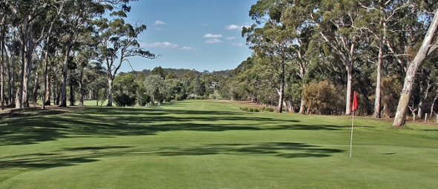
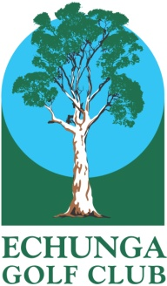

$

Echunga Women’s Pink Ribbon Day
Breast Cancer Fundraiser
This Photo by Unknown Author is licensed under CC BY-SA
Wednesday October 10th. 2018

Stableford – 8.30am for 9.00am shotgun start
A grade
B Grade
C Grade
Novelty Prizes

$25 for a game & homemade Yiros Lunch

Field limited to 60 players

Condition of play: wear something pink
Best dressed prize

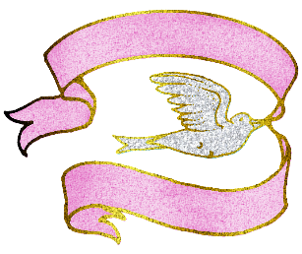...........

>>>>>>>>>>>>>>>>>>>>>>>>>>>>>>>>>>>>>>>>>>>>>>>>>>>>>>>>>>>>>>>>>>>>>>>>>>>>>>>

ENTRY FORM
(Entries close September 27th 2018 or when field is full. Check www.echungagolf.com.au)

Return with payment by email to: manager@echungagolf.com.au
or by mail to: Women’s Cancer Fundraiser Day, Echunga Golf Club, PO Box 53 Echunga, SA 5153
Name………………………………..…..…..…..…..……… Golflink No: …………………….............……….. GA hcp…………...….
Contact phone……………………………........……. Email address....………….........…………………………………………………
Home club……………………………………………… Type of payment: credit card/direct debit/cheque (circle one)

Name………………………………..…..…..…..…..……… Golflink No: …………………….............……….. GA hcp…………...….
Contact phone……………………………........……. Email address....………….........…………………………………………………
Home club……………………………………………… Type of payment: credit card/direct debit/cheque (circle one)

Name………………………………..…..…..…..…..……… Golflink No: …………………….............……….. GA hcp…………...….
Contact phone……………………………........……. Email address....………….........…………………………………………………
Home club……………………………………………… Type of payment: credit card/direct debit/cheque (circle one)

Payment options:
Credit card payment and cart bookings to Heather on: 8388 8038 or manager@echungagolf.com.au
Direct deposit: Account name: Echunga Golf Club BSB: 105 079 Account No. 305 186 540
Please use your name and Echunga Women’s Cancer Fundraiser as transaction description

Cheques by mail to Echunga Golf Club PO Box 53 Echunga SA 5153

